Tracing DNS with Wireshark

LAB # 05



Spring 2024
CSE-303L Data Communication & Networks Lab

Submitted by: Ali Asghar
Registration No.: 21PWCSE2059
Class Section: C

“On my honor, as student of University of Engineering and Technology, I have neither given nor received unauthorized assistance on this academic work.”

Submitted to:
Dr. Yasir Saleem Afridi

Date:
23rd April 2024

Department of Computer Systems Engineering
University of Engineering and Technology, Peshawar
The Domain Name System (DNS) translates hostnames to IP addresses, fulfilling a critical role in the Internet infrastructure. In this lab, we’ll take a closer look at the client side of DNS. Recall that the client’s role in the DNS is relatively simple – a client sends a query to its local DNS server, and receives a response back.
The hierarchical DNS servers communicate with each other to either recursively or iteratively resolve the client’s DNS query. From the DNS client’s standpoint, however, the protocol is quite simple – a query is formulated to the local DNS server and a response is received from that server.
Tracing DNS with Wireshark
• Open Wireshark and enter “ip.addr == your_IP_address” into the filter, where
you obtain your_IP_address with ipconfig. This filter removes all packets that
neither originate nor are destined to your host.
• Start packet capture in Wireshark.
• With your browser, visit the Web page: http://www.ietf.org
• Stop packet capture.
To print a packet, use File->Print, choose Selected packet only, choose Packet summary line, and select the minimum amount of packet detail that you need to answer the question.
- Locate the DNS query and response messages. Are then sent over UDP or TCP?
Ans: UDP
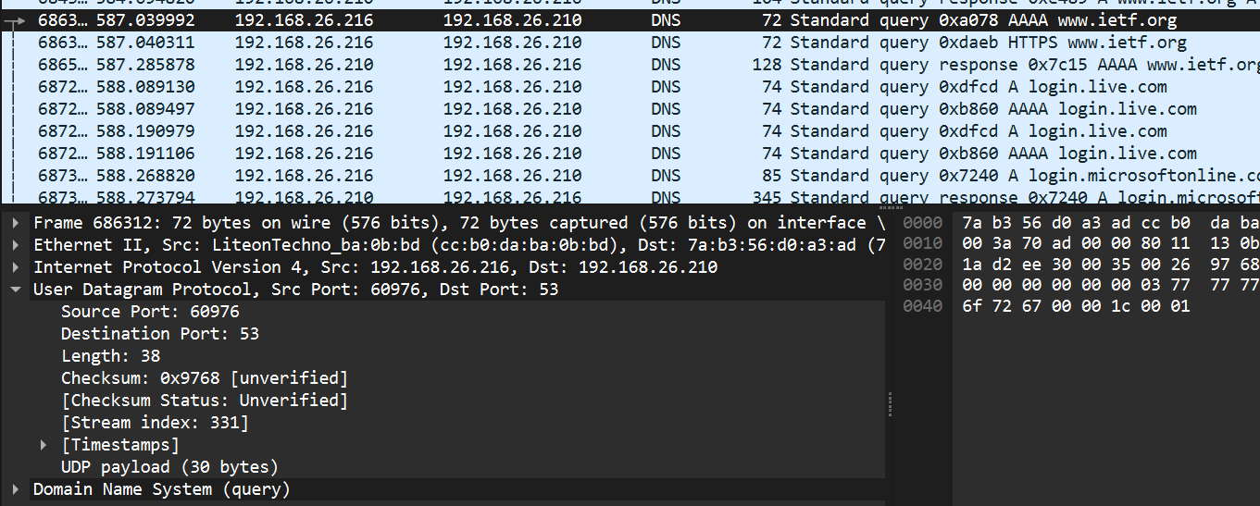

- What is the destination port for the DNS query message? What is the source port of DNS response message?
Ans: Source Port is 53 and Destination Port is 53
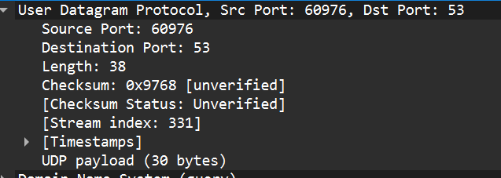

- To what IP address is the DNS query message sent? Use ipconfig to determine the IP address of your local DNS server. Are these two IP addresses the same?
Ans: The DNS query message is sent to 192.168.26.210. It is the same IP address as my local DNS server.
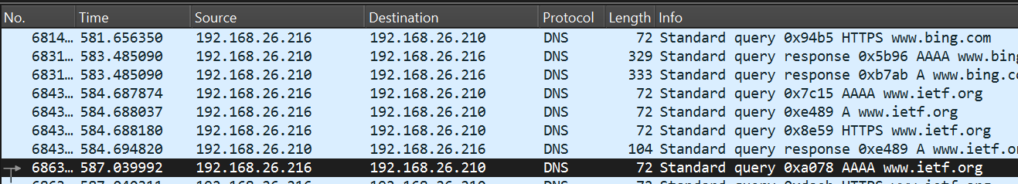
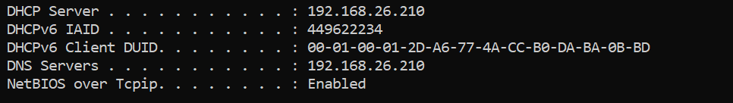

- Examine the DNS query message. What “Type” of DNS query is it? Does the query message contains any “answers”?
Ans: The type of DNS query is ‘A’ and DNS query message contains no answers.
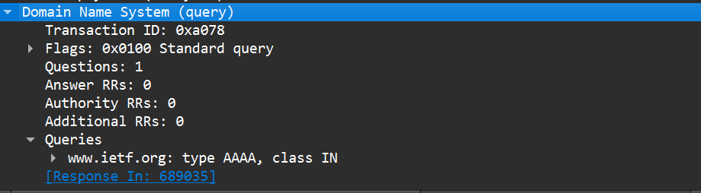
- Examine the DNS response message. How many “answers” are provided? What
do each of these answers contain?
Ans: Two Answers are provided.
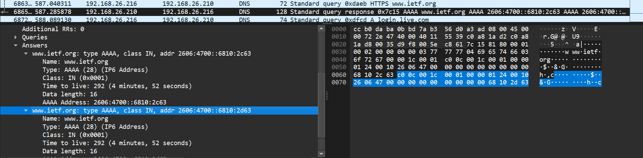
Each answer in the “Answers” section is represented by an RR. An RR consists of several fields, including:
- Name: The domain name for which the query was made (e.g., “www.example.com”).
- Type: The type of DNS record associated with the domain (e.g., A, AAAA, CNAME, MX).
- Class: The class of the record (usually “IN” for Internet).
- TTL (Time to Live): How long the answer can be cached (in seconds).
- Data Length: The length of the data field.
- Data: The actual data associated with the answer (e.g., IP address, domain name).

Now let’s play with nslookup.
• Start packet capture.
• Do an nslookup on www.mit.edu
• Stop packet capture.
You should get a trace that looks something like the following:
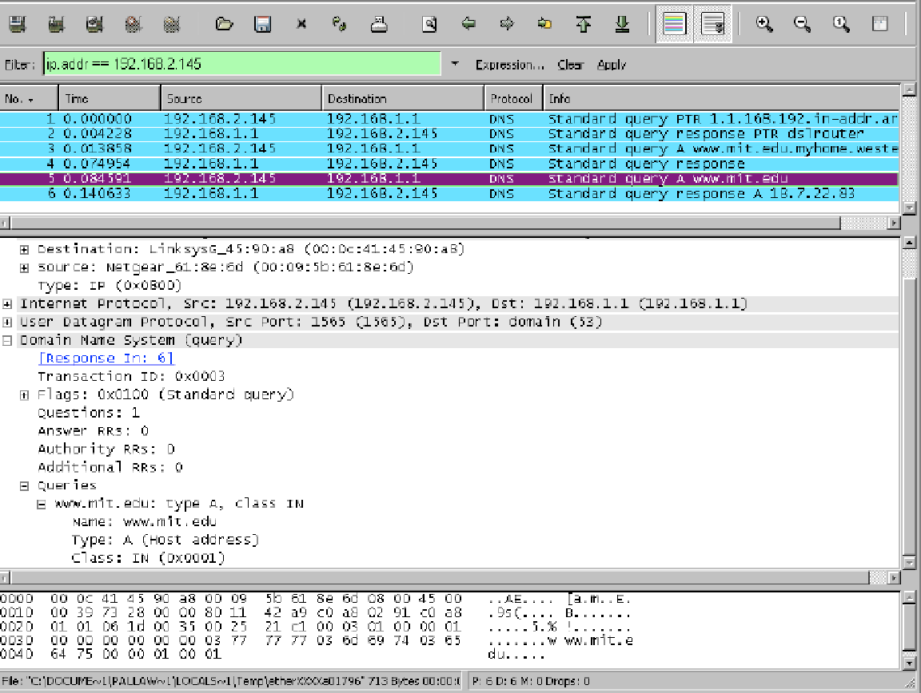
We see from the above screenshot that nslookup actually sent three DNS queries and received three DNS responses. For the purpose of this assignment, in answering the following questions, ignore the first two sets of queries/responses, as they are specific to nslookup and are not normally generated by standard Internet applications. You should instead focus on the last query and response messages.
- What is the destination port for the DNS query message? What is the source port of DNS response message?
Ans: Destination port of query: 53
Source port of response: 53
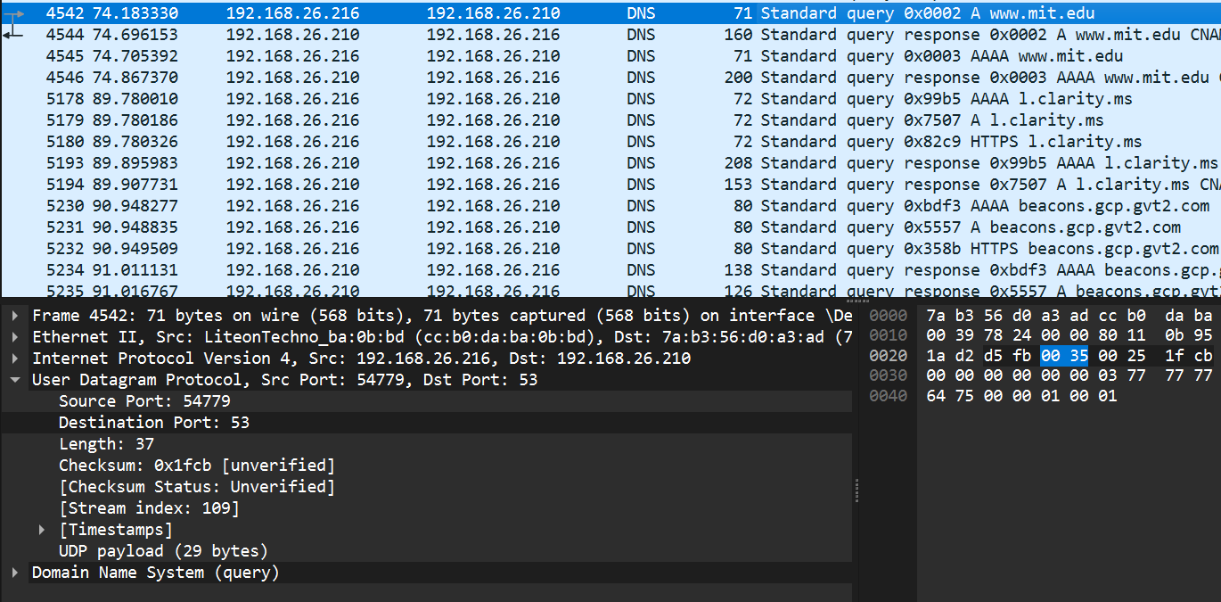
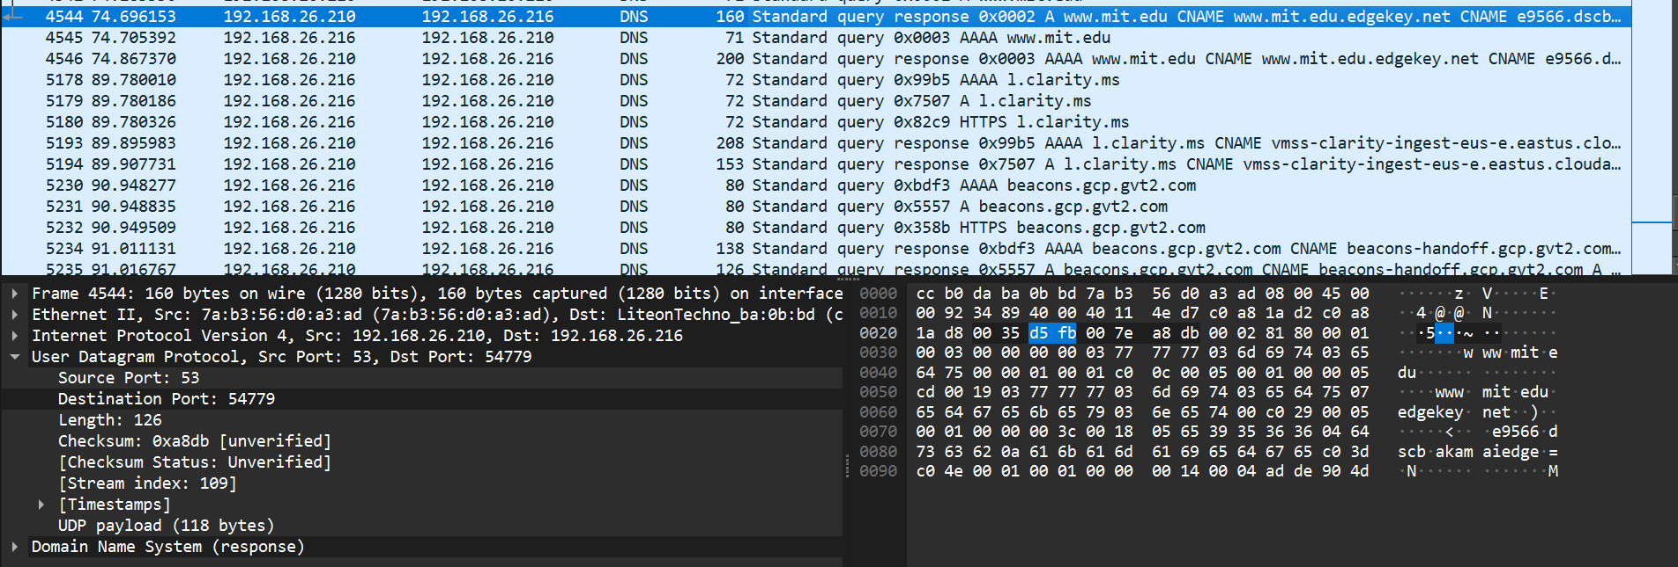

- To what IP address is the DNS query message sent? Is this the IP address of your default local DNS server?
Ans: Yes, it is same as default local DNS server(192.168..26.210).
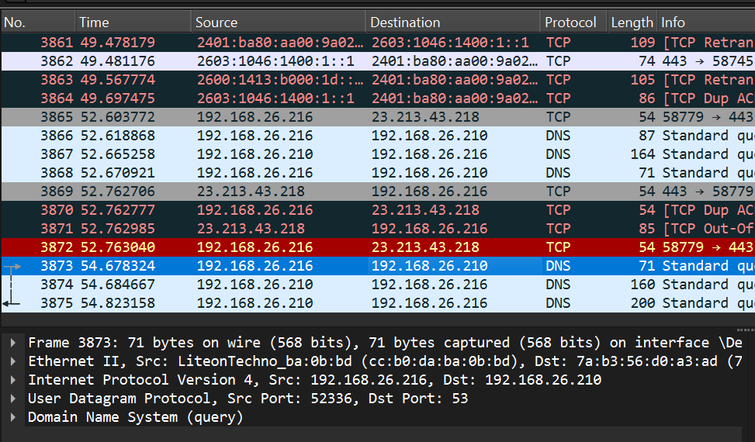
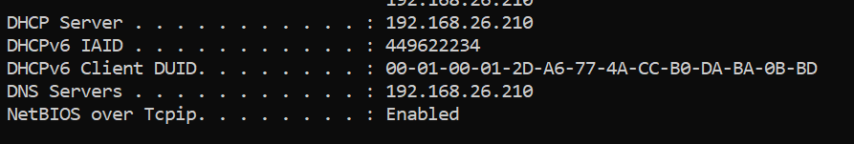
- Examine the DNS query message. What “Type” of DNS query is it? Does the query message contain any “answers”?
Ans: The type of DNS query is ‘A’ and DNS query message contains no answers.
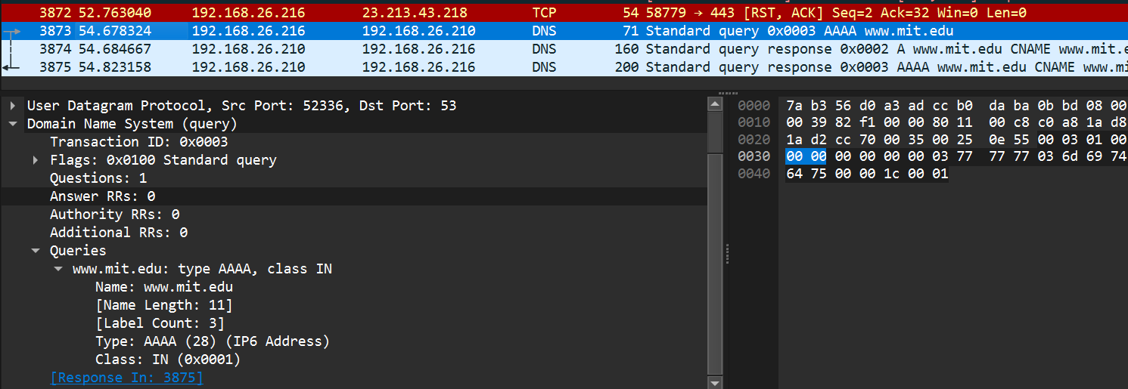

- Examine the DNS response message. How many “answers” are provided? What do each of these answers contain?
Ans: It contains 3 answers.
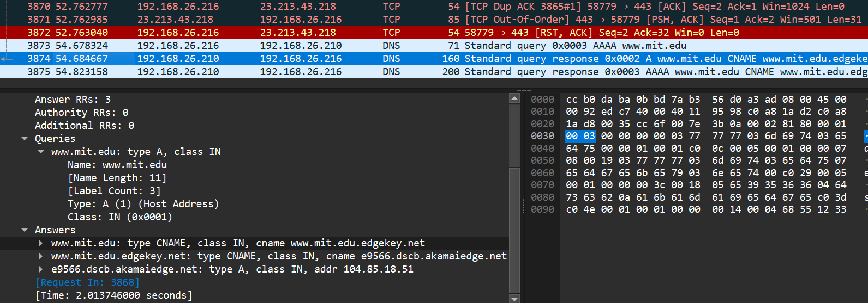

Each answer in the “Answers” section is represented by an RR. An RR consists of several fields, including:
- Name: The domain name for which the query was made (e.g., “www.example.com”).
- Type: The type of DNS record associated with the domain (e.g., A, AAAA, CNAME, MX).
- Class: The class of the record (usually “IN” for Internet).
- TTL (Time to Live): How long the answer can be cached (in seconds).
- Data Length: The length of the data field.
- Data: The actual data associated with the answer (e.g., IP address, domain name).

